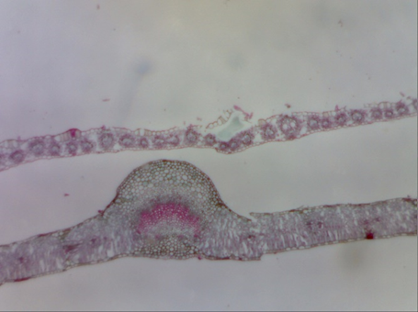
Image taken by | Taylor Winston, Ashleigh Clyde, Lucy Daniels,Madison Buka
Figure | #1
Organism | Monocot and Dicot Leaves
Total Magnification | x1000
Slide type | Cross section
Date | 10/24/2018

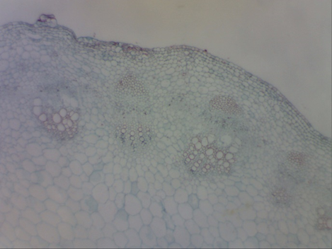
Image taken by | Ameer Alarab, Gabriel Isidro, Ali Qureshi, Kareeb Khan
Figure | #3
Organism | Monocot Stem
Total Magnification | x1000
Slide type | cross section
Date | 10/24/2018

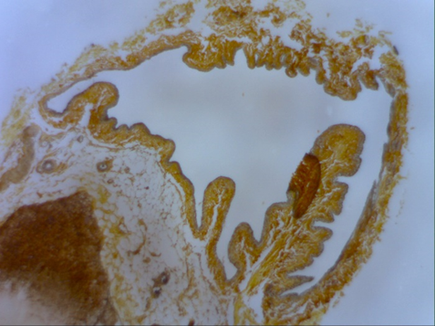

Image taken by | Cameron Cole, Jake Waldman, Krysteena Backer, Sara Beshir
Figure | #4
Organism | Adrenal Gland
Total Magnification | x1000
Slide type | cross section
Date | 10/24/2018

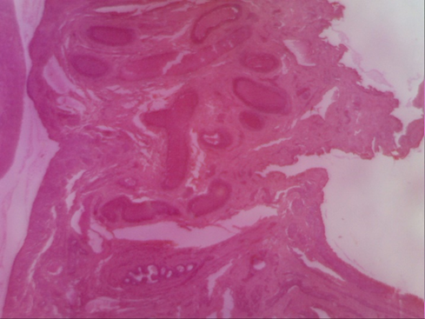
Image taken by | Angelo Alfonso, Cassie Mills, Chris Woodis
Figure | #6
Organism | Ovary of an immature cat
Total Magnification | x1000
Slide type | cross section
Date | 10/24/2018

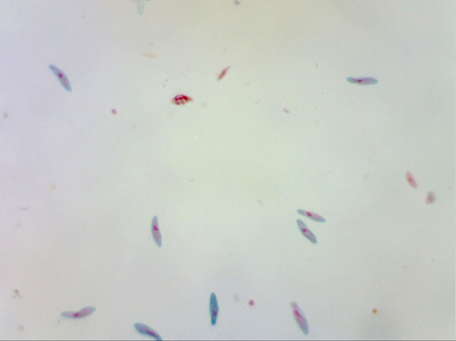

Image taken by | Akhnaton Namoh, Edwin Awuah, Nicholas Garcia, Jamyzahe Vaughan, Tuan-Minh Tran,
Figure | #7
Organism | Paramecium Caudatum
Total Magnification | x1000
Slide type | Wet mount
Date | 10/24/2018

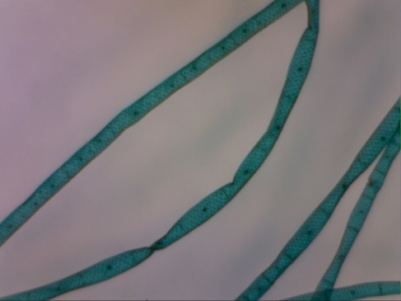

Image taken by | Diego Palacios, Sydney Craft, Maisha Farzana, Kayla Wooden,
Figure | #8
Organism | Spirogyra
Total Magnification | x1000
Slide type | Wet mount
Date | 10/24/2018

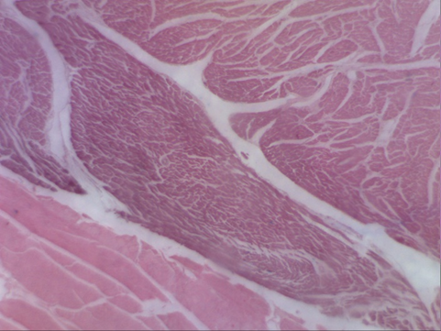
Image taken by | TJ Clark, Victor Lopez, Fatimah Hotaki, John Farrell
Figure | #10
Organism | Human Muscle Cell
Total Magnification | x1000
Slide type | Cross Section
Date | 10/24/2018

