Digital Image Example 2
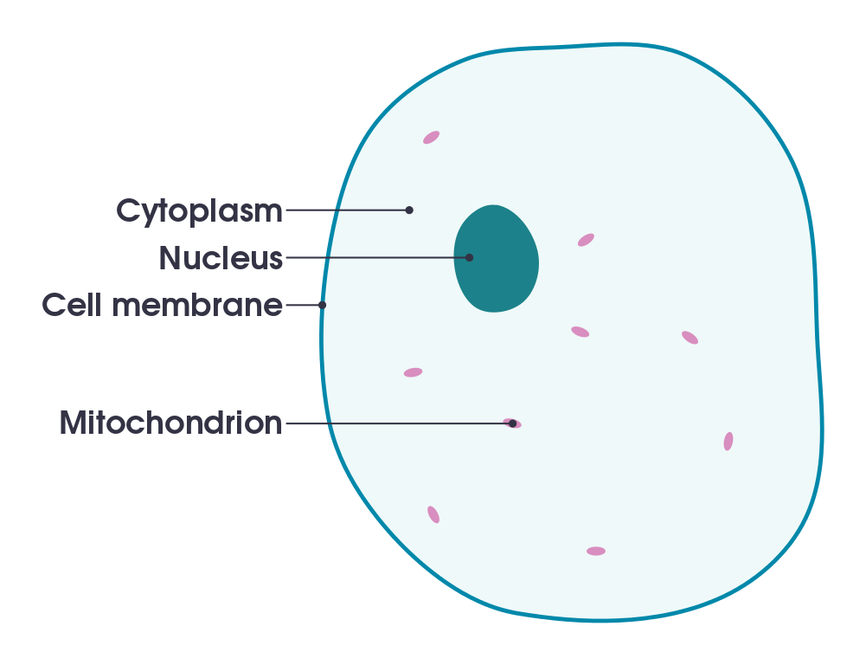
Digital Image #. Organism with all of organelles that have been labeled. Total Magnification and the Slide Type. Photo credit: First and Last name of every student in that group.

Vocabulary term (marked in the image)= (definition)_________________________________

Vocabulary term (marked in the image)= (definition)_________________________________

Vocabulary term (marked in the image)= (definition)_________________________________

Vocabulary term (marked in the image)= (definition)_________________________________

Explain how the vocabulary terms work together to help the organism function. You must use at least three vocabulary terms in your answer:
__________________________________________________________________________________________________________________________________________________________________________________________________________________________________________________________________________________________________________________________________________________________________________________________________________________________________________________________________________________________________________________________________________________________________

APA citation for PowerPoint Lecture:
____________________________________________________________________________________________________________________________________________________________

