Rabbit Dihybrid Cross Name: Period:
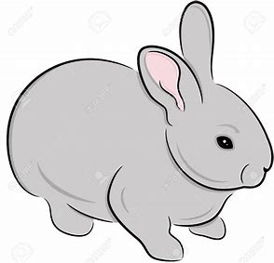
- In rabbits, grey hair is dominant to white hair.
- Also, black eyes are dominant to red eyes.
GG = gray hair Gg = gray hair gg = white hair
BB = black eyes Bb = black eyes bb = red eyes

- What are the phenotypes (descriptions) of rabbits that have the following genotypes?
- Ggbb ___________________
- ggBB ____________________
- ggbb ____________________
- GgBb ____________________

- What are the possible genotypes of rabbits that have the following phenotypes:
- Gray hair & black eyes ______________________________________

- Gray hair & red eyes ________________________________________

- White hair & black eyes ______________________________________

- White hair & red eyes ________________________________________

- A male rabbit with the genotype GGbb is crossed with a female rabbit with the genotype ggBb.
Find out the possible gamete combinations for the male and female rabbits, put them on your Punnett square, and fill it out to determine the ratio of the different phenotypes in the offspring.

- Male gamete combinations:
- Female gamete combinations:

- What is the ratio of offspring with grey fur and black eyes?
- What is the ratio of offspring with grey fur and red eyes?
- What is the ratio of offspring with white fur and black eyes?
- What is the ratio of offspring with white fur and red eyes?
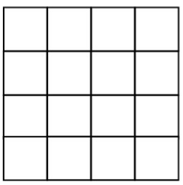

- A male rabbit with the genotype GgBb is crossed with a female rabbit with the genotype GgBb.
Find out the possible gamete combinations for the male and female rabbits, put them on your Punnett square, and fill it out to determine the ratio of the different phenotypes in the offspring.

- Male gamete combinations:
- Female gamete combinations:

- What is the ratio of offspring with grey fur and black eyes?
- What is the ratio of offspring with grey fur and red eyes?
- What is the ratio of offspring with white fur and black eyes?
- What is the ratio of offspring with white fur and red eyes?

- A male rabbit with genotype GgBb is crossed with a female rabbit with genotype ggbb. Find out the possible gamete combinations for the male and female rabbits, put them on your Punnett square, and fill it out.
Record all the different phenotypes of the offspring and their ratio.

