**Biology Unit 7 Genetics Notes Topic 2 Dihybrid Cross and Non-Mendelian Genetics**

*Objectives: SWBAT*

* *Determine the four possible gamete combination for dihybrid cross*
* *Predict the outcomes of a dihybrid cross by using Punnett square*
* *Differentiate between the non-Mendelian inheritance patterns of co-dominance and incomplete dominance*
* *Predict and interpret incomplete trait and codominant trait Punnett square crosses*

**What is Dihybrid Cross?**



* Genetic cross between parental generations that differ in _________traits.
* The genotype of the parent is represented by ______ alleles.

Example: **YyRr**

**What is dihybrid-cross Punnett square?**

* 16 square grid that is used to predict the genetic variations that result from crossing _________________ traits of two organisms.
* Each gamete has ______ allele for each trait (2 alleles).

Example:

T=tall t =short

R =red r = white

* These are the possible gamete combinations:

**TR** **Tr** **tR** or **tr**



**How to do the dihybrid-cross Punnett square?**

* Identify which trait is dominant and which is recessive
* Determine the letters for the alleles of each trait
* Write the genotype of each parent
* **Determine the possible gametes combinations for each parent**
* Draw a box with 16 squares
* Label each side of the box with the 4 gametes of each parent
* Put the dominant alleles First
* Cross the gametes
* Find out the offspring phenotypes
* Find out the offspring genotypes

**How can we determine the gamete combination?**



1. FOIL method:

F = first allele from each trait

O = outside allele from each trait

I = inside allele from each trait

L = last allele from each trait



*#1 homozygous dominant* **HHBB**

The possible gamete combinations are:

_____, _____, _____, ______



*#2 homozygous recessive* **hhbb**

The possible gamete combinations are:

_____, _____, _____, _______

*#3 heterozygous* **HhBb**

* The possible gamete combinations:



______ (first)

______ (outside)

______ (inside)

______ (last)

B) Crossing the two traits method



Example:

* The parent genotype is **HhBb**
* The alleles of the first trait are **Hh**
* The alleles of the second trait are **Bb**
* The possible gamete combinations are:

_________, ________, **_________, _________**

**Quick Practice**

* Find out the possible gamete combinations for this parent genotype **RrWw**

**________, ______, ________,_________**

* Find out the possible gamete combinations for the parent genotype **AAQQ**

________, ________, _________, ________

**Crossing homozygous X homozygous**

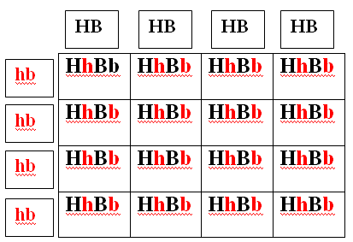

* Parental (P) generation:
* Phenotype: hairy&black X hairless&white
* Genotype: HHBB X hhbb
* 1st parent gamete combinations are:
* HB, HB, HB, HB
* 2nd parent gamete combinations are:
* hb, hb , hb, hb
* Offspring phenotypic ratio: 100% **hairy & black**
* Offspring genotypic ratio: 100% **heterozygous**

**Crossing Heterozygous X Heterozygous**



* Parental (P) generation:
* Phenotype: hairy&black X hairy&black
* Genotype: HhBb X HhBb
* 1st parent possible gamete combinations
* HB Hb hB Hb
* 2nd parent gamete combinations are:
* HB Hb hB Hb
* Offspring phenotypic ratio:
* __________ hairy & black
* __________ hairy & white
* __________hairless & black
* __________hairless & white

**Quick Practice**

* Cross two yellow and round pea plants that are heterozygous for BOTH traits **(YyRr)**
* The dominant traits: Yellow =Y Round =R
* The recessive traits: Green =y Wrinkled=r



* What are the possible gamete combinations?
* Gamete 1______ Gamete 2______
* Gamete 3______ Gamete 4______
* Offspring phenotypic ratios:
* _____________________, _____________________
* _____________________, _____________________

**Non-Mendelian Genetics**

There are other types of inheritance that do not follow Mendel’s laws:

* Incomplete Dominance
* Co-dominance
* Multiple Alleles
* Sex-linked
* Polygenic Traits

**Incomplete Dominance**

* There is _____ dominant or recessive alleles.
* None of the alleles of the same gene is ________________dominant over the other.
* The heterozygous phenotype is a __________ of the 2 homozygous phenotypes.
* Example: Homozygous red flowers (RR) crossed with homozygous white flowers (WW). Neither trait is completely dominant which results in _________________ pink flowers (RW).
* Heterozygous genotype shows phenotype that is a blend of both parents’ phenotypes.
* 3 different phenotypes (red, white, and pink)
* 3 different genotypes (RR, WW, and RW)
* NOTE: _____________________ alleles are used.

Incomplete Dominance Problem

Q1) What is the probability of having pink flowers if pink flowers are bred with red flowers?

Red genotype=RR White genotype=WW

|  |  |  |
| --- | --- | --- |
|  |  |  |
|  |  |  |
|  |  |  |

Pink genotype=RW

Answer:

_________ chance of Pink Flowers.

Q2) What is the probability of having white flowers if pink flowers are bred with pink flowers?

Red genotype=RR White genotype=WW

|  |  |  |
| --- | --- | --- |
|  |  |  |
|  |  |  |
|  |  |  |

Pink genotype=RW

Answer:

_________ chance of having white flowers.

**Co-dominance**

* ______dominant or recessive alleles. ______ traits show up in the offspring phenotype.
* *Co* means ______________
* Colors are __________________; they appear separately.
* Both alleles can be represented by _______________________.
* We can use ___________& _____________ when dealing with codominance to differentiate it from incomplete dominance for example: use "F" for the flower color allele.

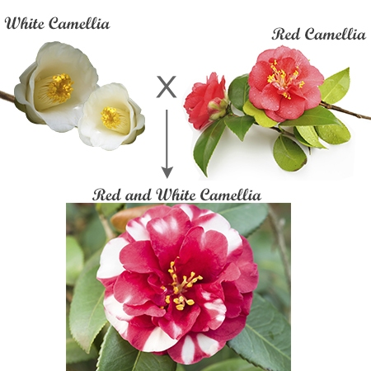

FR = allele for red flowers

FW = allele for white flowers

FRFW  = allele for spotted flowers

* In some varieties of chickens, the black feather allele is co-dominant with the white feather allele. The heterozygous chickens have feathers that are checkered black and white
* If we cross **black** chicken with **white** one, we will find out that:
* I will use letters and superscript in this example.

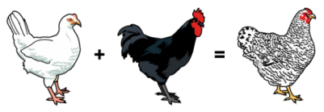

|  |  |  |
| --- | --- | --- |
|  | **FW** | **FW** |
| **FB** | **FB FW** | **FB FW** |
| **FB** | **FB FW** | **FB FW** |

Black **= FB FB**

White = **FW FW**

Checkered = **FB FW**

Offspring phenotype __________ checkered feather

Offspring genotype ____________ heterozygous

Solve this co-dominant case

* What are all the possible phenotypes and genotypes when two checkered chickens are bred?
* Let’s use capital letters in this case.

|  |  |  |
| --- | --- | --- |
|  |  |  |
|  |  |  |
|  |  |  |

Black = BB White = WW checkered= BW

Answer:

**Multiple Alleles**

* There are _________ than _______ alleles controlling one gene.
* However, ______________________________**______**are inherited.
* Example: Blood type gene is controlled by 3 alleles (**IA , IB & i).**

ABO system

* There are 4 blood types A, B, AB, & O which are determined by the type of ________ found on the surface of the red blood cells.
* Blood type A: red blood cells have _______________ on their surface.
* Blood type B: red blood cells have _______________ on their surface.

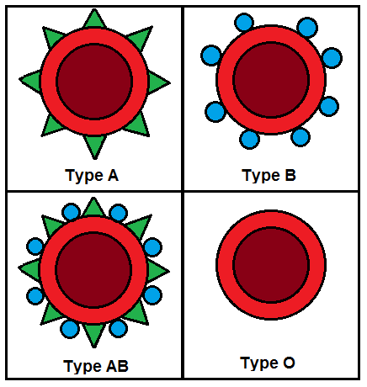

* Blood type AB: red blood cells have both _________________ on their surface.
* Blood type O: red blood cells have ______________ on their surface (naked).

Intersecting Fact About Blood Type

* Blood type displays co-dominance and complete dominance inheritance pattern.
* The relation between **IA & IB**  is __________________
  + So person with both **IA & IB** alleleshas blood type AB
* The relation between **IA & i** is _______________dominance.
  + **IA** is dominant allele**,** while **i** is recessive allele
  + Person with **IA & i** alleleshas blood type A

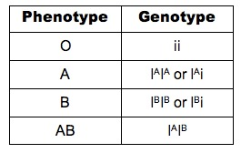

* The relation between **IB & i** is ___________ dominance.
* **IB** is dominant allele**,** while **i** is recessive allele
* Person with **IB & i alleles** has blood type B

Possible genotypes for blood types

1. Person with **blood type A** can be homozygous **IA IA** or heterozygous **IA  i**
2. Person with **blood type B** can be homozygous **IB IB** or heterozygous **IB i**
3. Person with **blood type AB** has only one genotype form which is heterozygous **IA IB**
4. A person with blood **type O** has one genotype form which is homozygous **ii**

Summary of ABO blood system

* There are ___ different alleles for blood type.
* There are ___ different genotypes.
* There are ___ blood types.

One more information about blood types

* Each blood type can be positive or negative
* This is determined by the presence of certain protein called **______________**
  + If red blood cells have Rh factor the person will have ____________
  + If red blood cells do not have Rh factor, the person will be ______________

Blood type problem #1

If a woman with AB blood has children with a man who has type O, what will be the possible genotypes of their children? What will be their blood types?

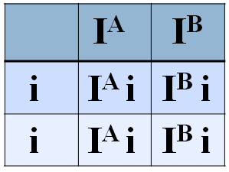

* Mother genotype = **IAIB**
* Father genotype= **ii**
* Offspring genotype:

50% IA i

50% IB i

* Offspring blood type (phenotype)

50% blood type _______

50% blood type _______

Solve blood type problem #2

Woman with type B blood has a child with type O blood. How is this possible if her husband has type A blood?

* Mother genotype =

|  |  |  |
| --- | --- | --- |
|  |  |  |
|  |  |  |
|  |  |  |

* Father genotype =

Offspring phenotypes

Offspring genotypes

**Sex-Linked Inheritance**

* Some traits are located on the sex chromosomes ___________ so the inheritance of these traits depends on the sex of the ___________ carrying the trait.
* Most known sex-linked traits are ____________ (carried on the X chromosome).
* This is probably because the X chromosome is much ___________ than the Y chromosome.
* Most of sex-linked traits are **______________** while the **normal gene is dominant.**
* Heterozygous Females  **XC Xc** are __________
* What is the meaning of “carrier”?
* **________________** recessive females (**XcXc**) have the trait.
* Males with one recessive allele on the X chromosome (**XcY**) have the trait because they do not have another **X** to counterbalance the affected gene.
* Males **________________** be carriers.
* Examples – color blindness, hemophilia, and male pattern baldness.

Color blindness (X-linked recessive trait) Case:

If a woman who is a carrier for color blindness gene (she has normal vision) has children with a man who has normal vision. What are the chances that they will have colorblind children? What are the chances that they will have colorblind carrier children?

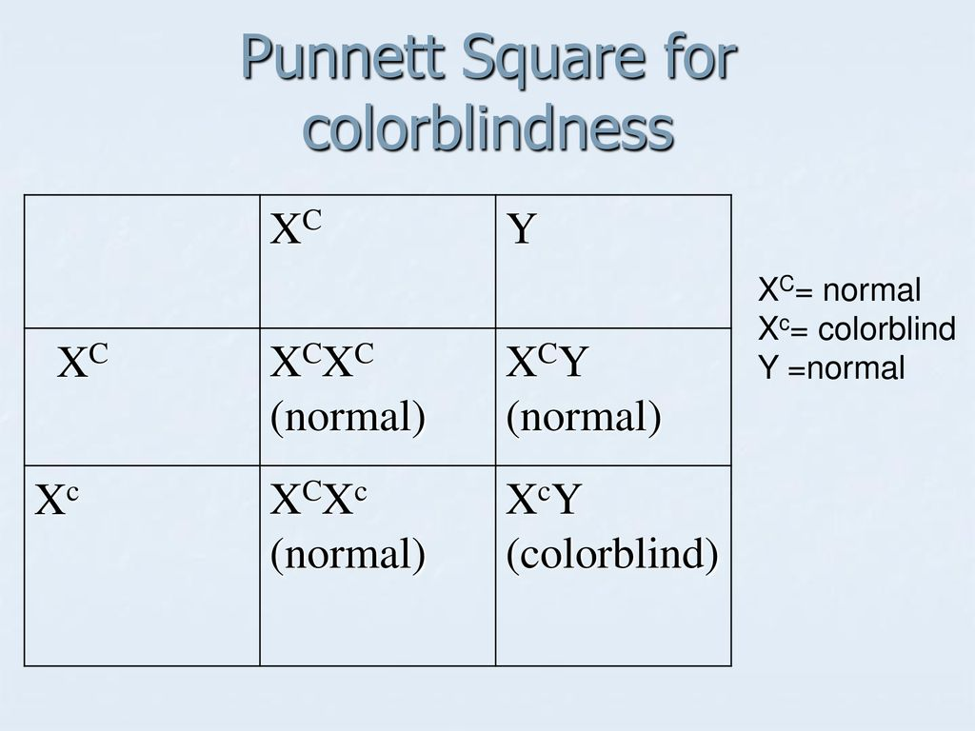

* **XC** is a chromosome with normal allele
* **Xc** is a chromosome with color blindness allele
* **Y**  is a normal chromosome

Probability of Colorblind children ____________

Probability of carrier children ________________

Think about this case

If a homozygous woman with normal vision has children with color blinded man, do you think the male children will be color blinded like their dad?

* Mother phenotype _______________

|  |  |  |
| --- | --- | --- |
|  |  |  |
|  |  |  |
|  |  |  |

* Mother genotype ________________
* Father phenotype _______________
* Father genotype ________________
* Offspring phenotype?

**Who Discovered The Sex-Linked Inheritance?**

* Thomas Morgan Studied fruit flies (*Drosophila melanogaster)*

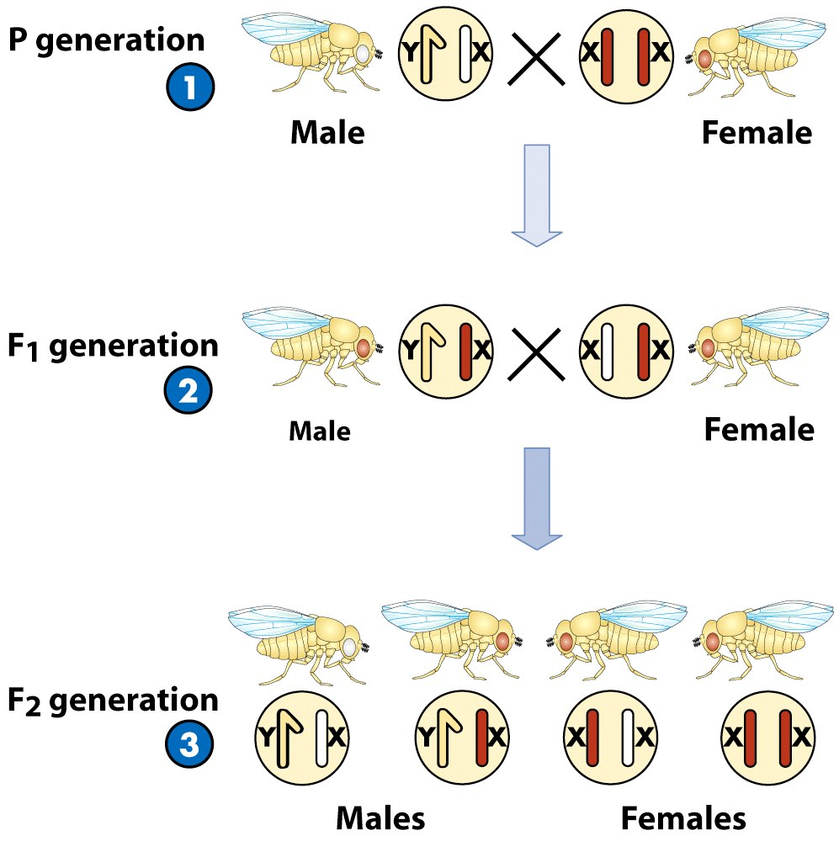

* He tested Mendelian inheritance.
* Morgan’s crossed white-eyed male & red-eyed female (normal eye color)
* Results of Morgan’s Experiment
* Eye color followed Mendel’s 3:1 ratio.
* All white-eyed fruit flies were males.

Morgan’s Conclusion

* White eyes were linked to ____________
* Some traits are sex-linked.
* Trait was found on X chromosome.
* Red eye allele is _______________ **XR**
* White eye allele is ______________ **Xr**
* Females have 2 possible genotypes & 1 phenotype (red eye):
  + Homozygous red-eyed **XR XR**
  + Heterozygous red-eyed **XR Xr**
* Males have 2 possible genotypes & 2 phenotypes:
  + Red-eyed **XR Y**
  + White-eyed **Xr Y**

Punnett Square For Morgan’s Experiment

Cross **heterozygous red**-eyed female with white-eyed male.

Cross **homozygous** red-eyed female with white-eyed male.

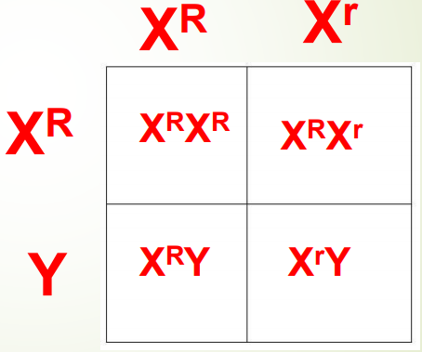

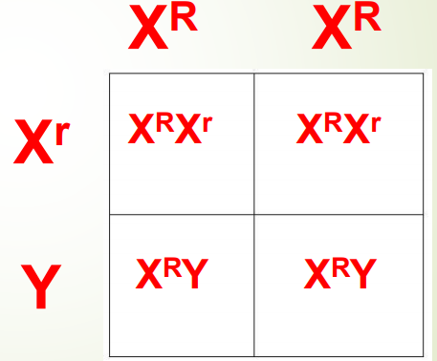

.

Offspring phenotype ratio:

* 50% red-eyed females
* 25% red-eyed males
* 25% white-eyed males

Offspring phenotype ratio:

* 50% red-eyed females
* 50% red-eyed males

**Polygenic inheritance**

* Polygenic traits are traits that are controlled by ________ or ________ genes.
* Polygenic = having many genes.
* When multiple genes act together to produce a physical (phenotypic) character, **__________** of differences occurs.
* Examples:
  + Human height
  + Eye color
  + Skin tone is determined by 4-6 genes—that means that there may be 4-6 different chromosomes involved!

**Environmental Effect on Genes Expression**

* Characteristics are not solely determined by genes, but they are also determined by the interaction between genes and the environment.
* Environmental factors such as diet, temperature, oxygen level, humidity, light cycles, and the presence of mutagens can all impact which of an animal's genes are expressed, which ultimately affects the animal's phenotype.

Thermosensitivity of freshwater turtle embryos

* Scientists have shown that intermediate temperatures (28.5°C) can yield a mixed of both males and females turtle
* The thermosensitive period that regulates sex differentiation last about 2 weeks during the middle of the development of the animal.
* At 30°C (during thermosensitivity period) all *E. oribicularis* to be females
* At 25°C only males hatch.